Important Information Regarding Health Insurance:

M&M Cartage offers a 4-tier premium structure, which means instead of a standard premium for the coverage you selected, you will have the opportunity to qualify for four different pricing tiers. Where you fall on the tier will depend on a points system. If you complete a biometric screening and health risk assessment (M&M offers this yearly), you will receive points based on where you fall on the range for BMI, tobacco usage, cholesterol, glucose, etc. Please see the chart below for an example. Participating in educational programs will also earn you points.

The information from your health risk assessment and the results from your biometric screening will be used to provide you with information to help you understand your current health and potential risks. M&M will not see your results from your biometric screening and health risk assessment. This is all handled by a third party company, Healthsync, who has been completing these screenings for us for years.

Tier 1: 500-600 Tier 2: 300-499 Tier 3: 1-299 Tier 4: Non-Wellness Participants

Below is a complete listing of how points can be earned yearly.

Measure | Range | Point Value
Online HRA | Completed | 25
Body Mass Index (BMI) | BMI < 30 | 25
Tobacco Usage | Non-user | 125
Cholesterol | HDL > 40 | 50
 | LDL < 130 | 50
 | Triglycerides < 150 | 75
Fasting Glucose | Glucose < 100 | 75
Blood Pressure | BP < 140/90 | 75
Educational Programs  Includes: Onsite Educational classes offered, Exercise Class, Onsite Disease Mgt Clinic participation)  Additional Offerings to come | 50 pts per class, max 2 | 100
Total Points Available per person on health plan |  | 600
Healthsync
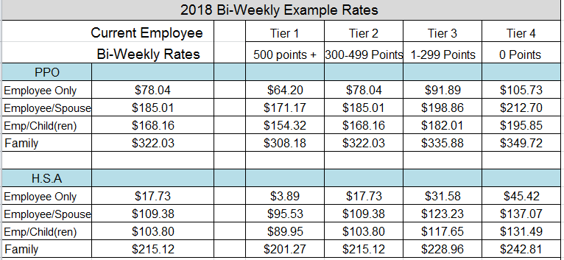

The biometric screenings and educational programs are offered annually. (For new hires, you have 30 days from your hire date to complete the biometric screening, health risk assessment, and educational programs.) Your participation and results will determine your points and where you fall on the tier (see chart on previous page). No participation in the wellness programs offered will place you in Tier 4. The rate table above will show you what the premiums will be on a bi-weekly basis.

If you have any questions, please contact the HR Manager, Stacey, at ext 236.

