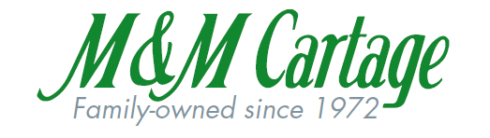
We would like to introduce to you M&M Cartage’s uniform program! We have partnered with Cintas to bring new and exciting uniform options to our employees. Listed below are the steps to access and use the catalog to view and select your uniform options:
- Go to www.mycintas.com
- Use the My Cintas ID, “mmcartage”
- Use your last name followed by the first initial of your first name as your login
- You will then create your own password
- You will then answer security questions in case you forget your password
- If you order something with the M&M logo on it, it is NON-REFUNDABLE/NON-RETURNABLE.
- Please order the correct size. If you are unsure of your size, please contact Tyrone as he will have size samples.
- Click the Driver’s Apparel Section and begin to look at all the options!
All employees are expected to be in uniform every day and must keep uniforms clean and neat. This is a great opportunity to expand your workplace wardrobe with a free $150 credit preloaded to your account. If you spend more than the $150 credit, you will be contacted by Cintas and they will verify your identity and order, you will then be asked to pay the overdue balance. The $150 credit is only good for one year; therefore the credit you will receive this month will expire on the 1st of the same month the next year. After that, you will receive your $150 credit each year, in the same month. Any unused credit from the previous year will be forfeited (if any is left over). M & M Cartage expects its employees to maintain a professional image at all times. You are the most visible representative of M & M Cartage. In fact, your appearance may be the only factor by which the public and many customers judge M & M Cartage on our professionalism, safety, and reliability.
*Any further questions about our partnership with Cintas should be directed toward Krista Wheeler at 502-456-4586 x 202 or krista.wheeler@mmcartage.com
**Returns should be sent directly back to Cintas with the return form that will be included in the order when it arrived. Please do not bring any returns to M&M as we will NOT be processing returns to Cintas.

