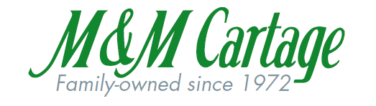
*IMPORTANT 401K INFORMATION*
M&M Cartage employees are automatically enrolled in the 401K plan. Your employee contribution will be set at a deferral rate of 2% and will be invested into a retirement age based plan. If you DO NOT want to participate in the 401K plan, you MUST OPT OUT. To opt out, you will need to call Ascensus at 1-866-809-8146 within 30 days of your hire date.
Your eligibility date is the 1st of the month after you have been employed here for 90 days. For example; if you were hired on April 14th, 2018, you will be automatically enrolled starting August 1st, unless you opt out. M&M will match half of every % up to 6% that you choose to contribute to your 401K! This means that if you contribute 6% of your check every pay period, M&M will contribute 3% on top of that, every pay period. Again, your employee contribution will be set at the deferral 2% and will be invested into a retirement age based plan. If you would like to increase your contribution or change your investment options, you can do so by registering on https://myaccount.ascensus.com/rplink via the steps below:
- Go to https://myaccount.ascensus.com/rplink and look for Set Up Your Online Account at the bottom of the screen, then click Get Started
- Enter your social security number, date of birth and zip code and click “Next”
- On this page you will set up any remaining account information and security questions, If you have any questions about setting up your account please contact your HR Manager Stacey Murphy at extension 236
- After these steps are completed, please contact your M&M Cartage Financial Advisor Justin Wagner for advice on setting up your contributions
Brett Mahle
502-394-4006
brett.mahle@morganstanley.com
See booklet included in packaging for further financial guidance and decision making, for any questions, please contact Stacey Murphy at ext. 236.

